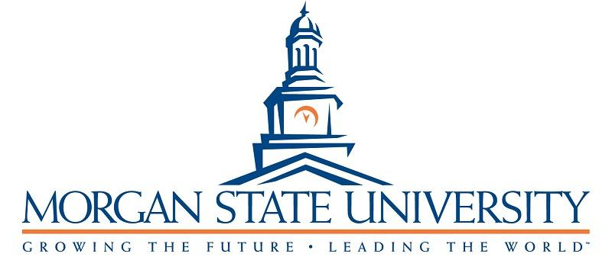
June 30, 2022

Joseph Schmoe
Program Officer
Main Funding Agency
123 Main Street
Anytown, MD 1111
schmoe@mainfunding.org

RE: No-Cost Extension Request for Main Funding Agency-Funded Cooperative Agreement #123ABC (PI: Dr. Suzy Queue)

Dear Mr. Schmoe,

Morgan State University (MSU) is requesting a no-cost extension of the Main Funding Agency-funded Cooperative Agreement, #123ABC (PI: Dr. Suzy Queue), entitled “Proposal Title” from 09/01/20 to 08/31/22, for 12 months. This Cooperative Agreement has been funded for $100,000.

During the no-cost extension period, Dr. Queue plans to complete some of the activities that were left incomplete due to the Covid-19 pandemic. Years 1 and 2 of the project were from September 2020 to August 2022, which coincided with the Covid-19 pandemic that reached high levels in the United States starting March 2020. The primary goal of MSU’s “Proposal Title” project is to work with community-based organizations to address issues that result in increased illegal drug usage. We tried our best to keep the members of the communities involved in the coalition via Zoom and other social media platforms. However, given business closures, time changes for certain businesses, and other State mandated mitigation strategies that precluded community gatherings, some parts of the projects had to be postponed for approximately 12 months. The no-cost extension will allow us to complete those activities.

Enclosed please find the following documents:
- Budget and budget justification for the intended activities;
- Timeline for completion of the intended activities.

Please do not hesitate to contact me if you have any questions or concerns. We thank you for considering this request.

Sincerely,

Farin Kamangar, MD, PhD
University Distinguished Professor
Assistant Vice President for Research
Morgan State University
Email: farin.kamangar@morgan.edu
Cell Phone: 301-655-9280

