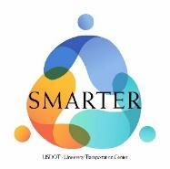
SMARTER Center Scholarship Application Form
The SMARTER Center is seeking dedicated transportation students for its annual scholarship award. As part of the program, accepted applicants will receive reimbursement for the cost of tuition and work with transportation faculty and researchers at Morgan State University. SMARTER interns will be responsible for staffing the SMARTER Innovation Lab during specified hours. To submit your application, please upload this form, a resume, and a recent copy of your transcripts to the google form listed here.
Name
Email
Major/Program
Are you a US citizen?
High School
Note: This fellowship is only open to those who graduated from high school in the US.
Short Essay (1-2 paragraphs)
Describe a problem or challenge currently affecting the transportation sector and discuss how you would like to address it. What knowledge or skills would you need to adequately address the issue? How would a scholarship from the SMARTER Center help you achieve this goal?

