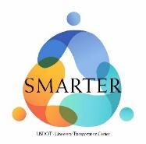
SMARTER Community Engagement Form
The SMARTER Center favors projects that demonstrate robust community engagement practices during and after the research process. Principal investigators who share their findings with communities and institutions outside of academia allow the Center to fulfill its obligations to USDOT, transit operators, and the communities they serve. This form is meant to document this service. Please submit this form by month 18 of your research program (see Request for Proposals) to Joseph Niehaus at joseph.niehaus@morgan.edu.

Project Title
Principal Investigator(s)
Universities Involved
Email Address(es)

Response
Identify any groups, organizations, or individuals (excluding academia and private industry) that were meaningfully engaged over the course of the project. Describe the nature of your collaboration, noting any data collection/dissemination, surveys, workshops, or other activities you performed as a result of the partnership. How did the community benefit from your work?

